Game Hardware 3

CA Project

Submitted by Liam Ross (A00282639)

**Introduction:**

This aim of this project was to use the OpenCV python package along with trained algorithms to detect specific objects in images and videos.

For my project, the detection methods I chose were, face and eye detection, face and smile detection, car detection and number plate detection. I chose these detection methods as I found them to be the most interesting and I felt that I could generate a lot of samples. I sourced various images and videos online to use for my project, which can all be found in the Code/images and Code/videos folders. I have also included links to the original sources for all these images and videos below.

The Python package that I used in this project was OpenCV. OpenCV is an open source, cross platform, library of programming functions aimed at real time computer vision.

**Software Used:**

OS:

* macOS Monterey – Version 12.4

Python:

* Version: 3.10

Packages:

* OpenCV – Version: 4.6.0.66
* Numpy – Version: 1.23.5

Environment

* PyCharm IDE – Version 2022.2.4

Classifiers:

* haarcascade_russian_plate_number.xml
* haarcascade_car.xml
* haarcascade_frontalface_default.xml
* lbpcascade_frontalface_improved.xml
* haarcasade_smile.xml
* haarcascade_eye.xml

Python Source Code:

* CarsImage.py
* CarsVideo.py
* FaceAndEye.py
* NumberPlate.py
* NumberPlateVideo.py
* Smile.py

**Detections:**

Face and Eye Detection

Classifiers Used: haarcascade_frontalface_default.xml & haarcascade_eye.xml

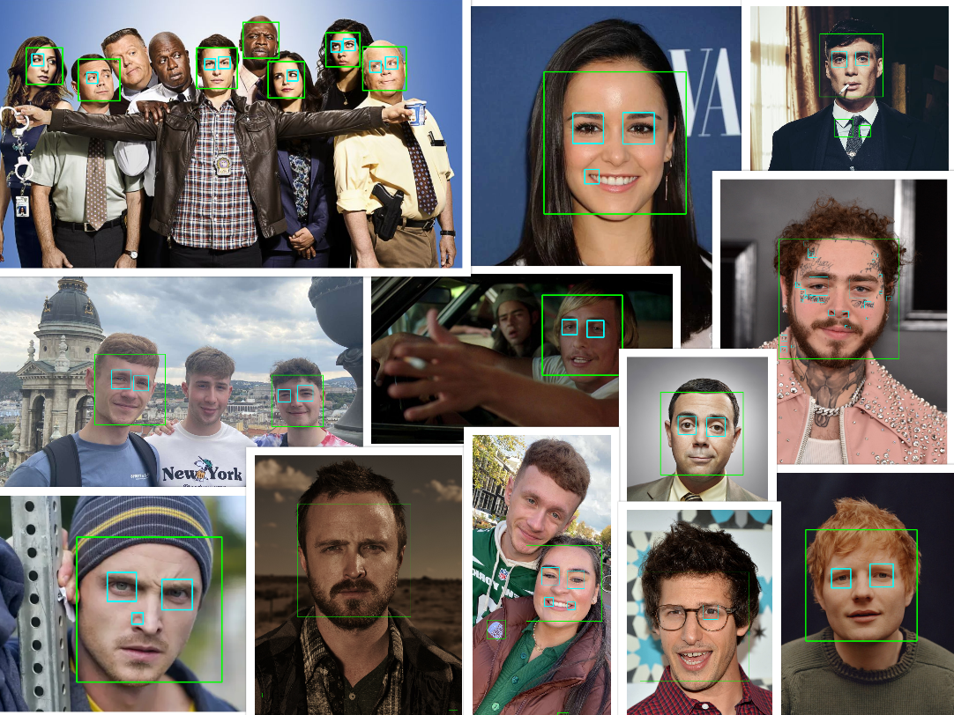

Figure : Results from Face and Eye Detection Sample 1.

Classifiers Used: lbpcascade_frontalface_improved.xml & haarcascade_eye.xml

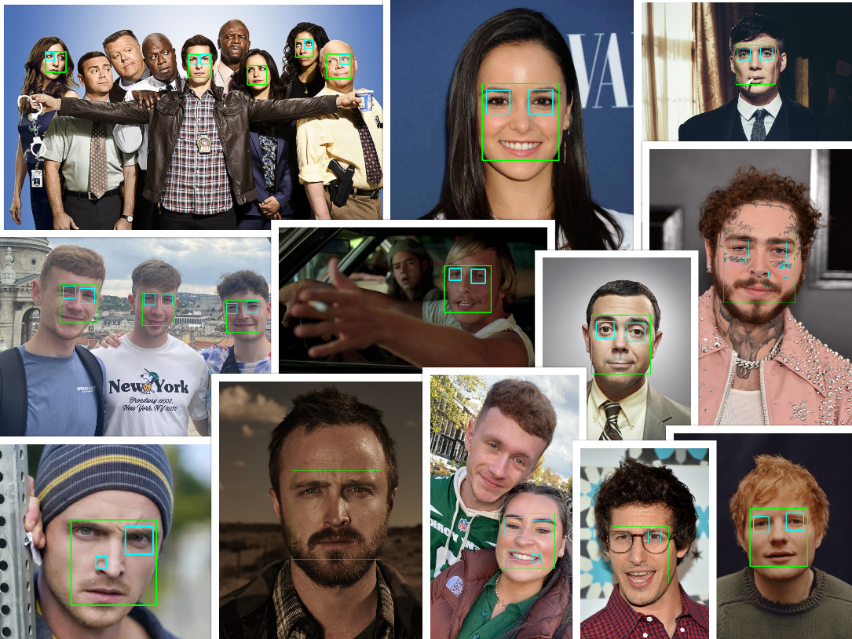

Figure : Results from Face and Eye Detection Sample 2.

For face and eye detection, I ran two detection samples with two different face classifiers on each of the sample images that I gathered. In the first sample, I used the haarcascade_frontalface_default classifier and in the second sample I used the lbpcascade_frontalface_improved classifier. I used the haarcascade_eye classifier on both samples. The green boxes indicate a facial detection, and the cyan boxes indicate an eye detection.

My goal was to see which classifier was more accurate for facial detection and what effect that had on detecting the eyes. From Figure 1 and Figure 2 above, you can see that both classifiers gave very similar results in most cases. I think that the lbpcascade_frontalface_improved classifier was more accurate in detecting faces and it gave off fewer invalid detections. As you can see from Figure 3 below, the image on the left contains two invalid facial detections around the upper chest area, indicated by the arrows, whereas the image on the right does not.

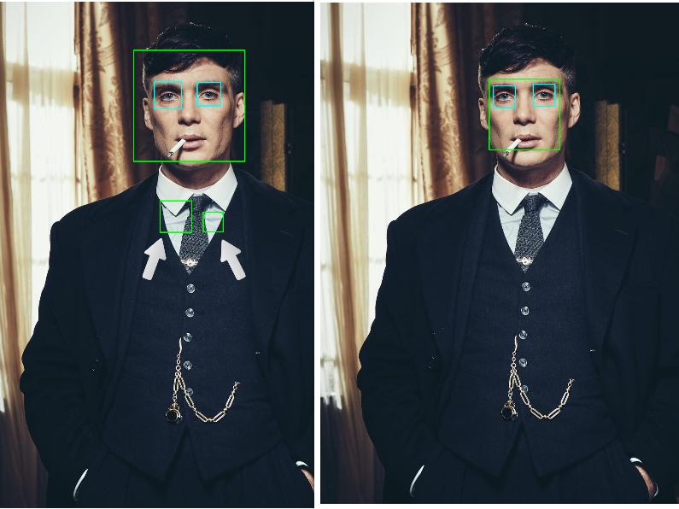

Figure 3: Left: haarcascade_frontalface_default.xml, Right: lbpcascade_frontalface_improved

I also believe that, in most cases, because the lbpcascade_frontalface_improved classifier gave a more accurate facial detection, it led to a more accurate eye detection, as well as few invalid detections. As you can see from Figure 4 below, the face of the man in the middle on the top image was not detected at all, whereas in the bottom image, his face was detected which then led to his eyes also being detected. You can also see just from the green boxes, indicating a facial detection, in both Figure 3 and Figure 4 for the lbpcascade_frontalface_improved classifier that they are much smaller than the lbpcascade_frontalface_improved classifier.

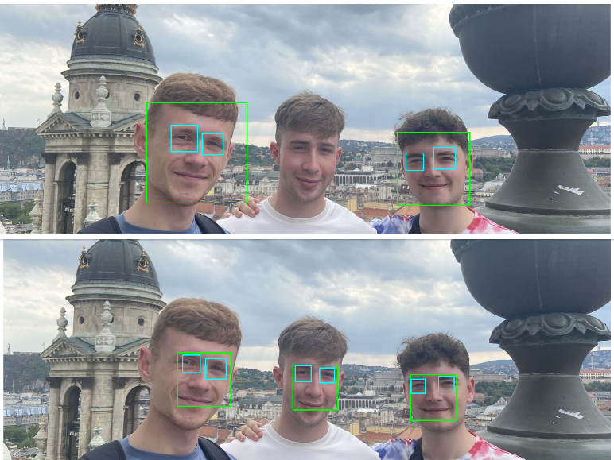

Figure 4: Top: haarcascade_frontalface_default.xml, Bottom: lbpcascade_frontalface_improved

Face and Smile Detection

Classifiers Used: lbpcascade_frontalface_improved.xml & haarcascade_smile.xml

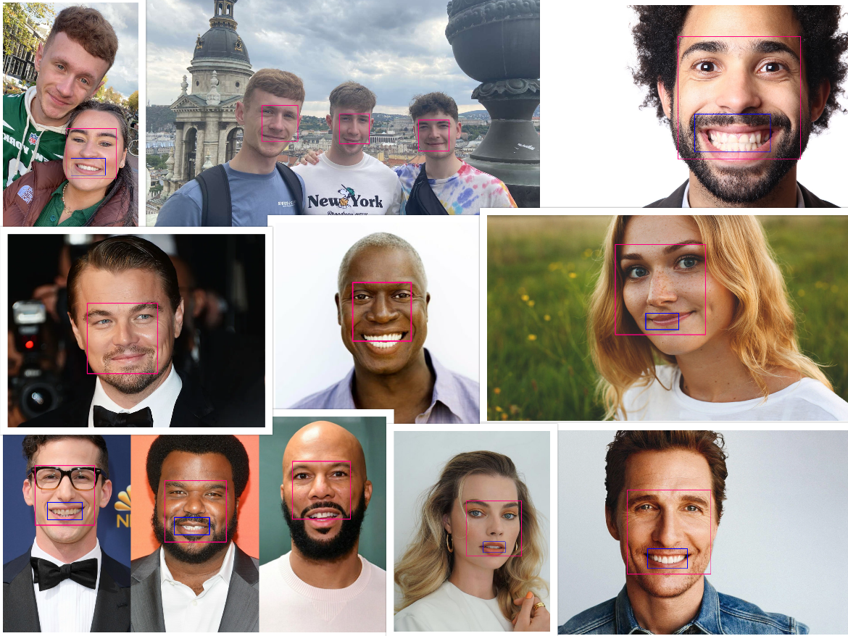

Figure 5: Results from Face and Smile Detection.

For face and smile detection, the classifiers I used were lbpcascade_frontalface_improved and haarcascade_smile. I decided to use lbpcascade_frontalface_improved for the facial detections as I deemed it to be more accurate.

Number Plate Detection

Classifiers Used: haarcascade_russian_plate_number.xml

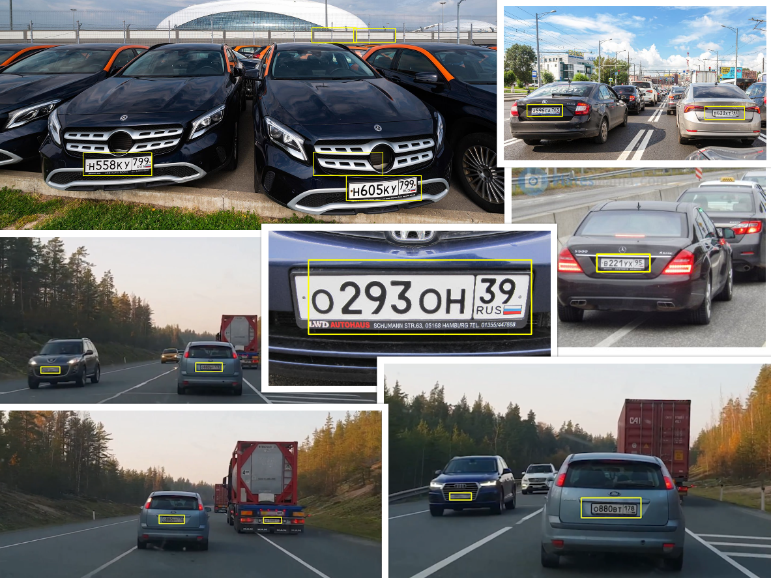

Figure 6: Results from Number Plate Detection Sample 1.

Classifiers Used: haarcascade_russian_plate_number.xml

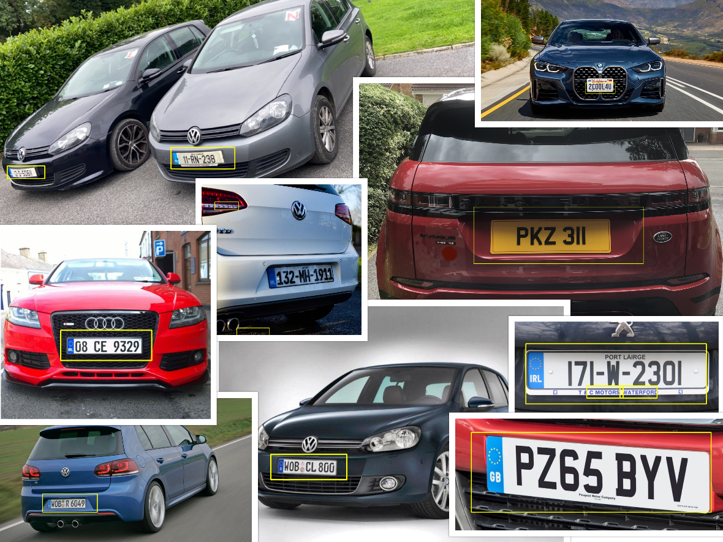

Figure 7: Results from Number Plate Detection Sample 2.

For number plate detection I used the haarcascade_russian_plate_number. I ran two sample detections with this classifier. In the first one was, I used only Russian number plates and the in the second one, I used a variety of number plates, including Irish, English, and German. I felt the need to run these two samples as I was originally under the impression that the classifier would only be able to detect Russian number plates as the name suggested. Upon running the second sample, I found myself to be wrong as the classifier worked for almost all kinds of number plates. Despite the fact that the classifier worked all number plates, I did find that Russian plates were more easily detected.

Car Detection

Using haarcascade_car.xml

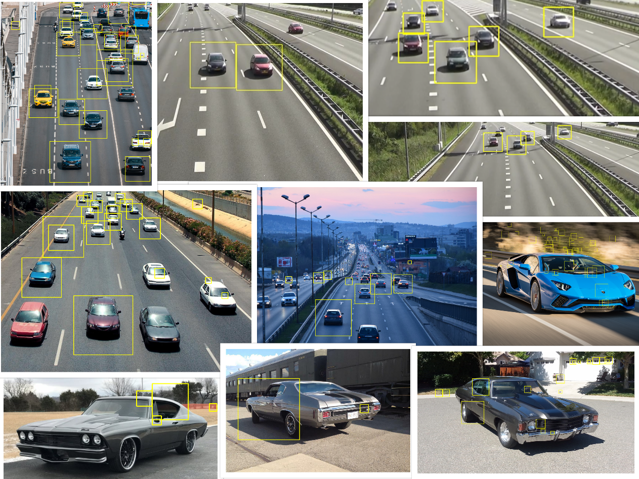

Figure 8: Results from Car Detection.

**Report**

Blah

**References:**

**Images:**

cars.jpeg: <https://pixabay.com/photos/highway-city-cars-traffic-road-7213206/>

cars1.jpeg: <https://driversed.com/trending/the-best-defense-preparing-to-share-the-road-with-self-driving-cars>

chevelle70.jpg: <https://www.barrett-jackson.com/Events/Event/Details/1970-CHEVROLET-CHEVELLE-SS-454-180621>

chevelle68.jpg: <https://www.mecum.com/lots/SC0519-371993/1968-chevrolet-chevelle/>

chevelle71.jpg: <https://www.mecum.com/lots/CA0814-190004/1971-chevrolet-chevelle-heavy-chevy/>

golf1.jpg: <https://car-recalls.eu/recall/volkswagen-golf-2011/>

golf2.jpg: <https://www.motorauthority.com/news/1035199_2011-volkswagen-golf-r-preview>

b991.jpg: <https://www.tvinsider.com/949404/brooklyn-nine-nine-police-brutality-season-8-storyline/>

post.jpg: <https://www.pinterest.ie/pin/389631805266435293/?amp_client_id=CLIENT_ID%28_%29&mweb_unauth_id=&amp_url=https%3A%2F%2Fwww.pinterest.com%2Famp%2Fpin%2F389631805266435293%2F&amp_expand=true>

tommy.jpg: <https://nyla-hurst.blogspot.com/2021/04/tommy-shelby-peaky-blinders-wallpaper.html>

dazed3.jpg: <https://wallpapercave.com/dazed-and-confused-desktop-wallpapers>

smileWoman.jpg: <https://www.healthline.com/health/types-of-smiles>

smileMan.jpg: <https://www.plowzandmowz.com/smiling-man/>

leo.png: <https://www.self.com/story/leonardo-dicaprio-is-the-internets-most-beloved-actor>

matthew.png: <https://wallpapercave.com/matthew-mcconaughey-wallpapers>

boyle.jpg: <https://www.imdb.com/name/nm0516266/>

amy.png: <https://brooklyn99.fandom.com/wiki/Melissa_Fumero>

jesse1.png: <https://www.charactour.com/hub/characters/view/Jesse-Pinkman.Breaking-Bad>

jake.jpg: <http://t0.gstatic.com/licensed-image?q=tbn:ANd9GcQ1qm-SJisBykeFD5VZiAGqzLR3NAoCBdf1hs4wCFKmvap8IZJ_5oS5ZA28QmOngR07j1-0VUwtoJDUPLU>

numberPlate.jpg: <https://licenseplatemania.com/landenpaginas/rusland.htm>

numberPlate1.jpg: <https://platesmania.com/ru/nomer11962743>

numberPlate2.jpg: <https://www.roadpol.eu/index.php/numbers-reveal-illegal-russian-licence-plates>

numberPlate3.jpg: <https://www.rbth.com/lifestyle/334097-russian-license-plates>

americanPlate.jpg: <https://www.bmwblog.com/2020/06/04/how-does-the-u-s-license-plate-look-on-the-new-bmw-4-series-coupe/>

irishPlate.jpg: <https://licenseplatemania.com/landenpaginas/ierland.htm>

irishPlate1.jpg: <https://standoutplates.ie/product/3d-white-irish-plate-county-and-irl-german-font/>

irishPlate2.jpg: <https://www.plates.ie/>

englishPlate.jpg: <https://www.autotrader.co.uk/content/advice/how-does-the-number-plate-system-work>

englishPlate1.jpeg: <https://www.evoqueownersclub.co.uk/threads/number-plate-sizes-and-shapes.17830/>

**Videos:**

cars.mp4: <https://pixabay.com/videos/traffic-car-highway-street-27260/>

numberPlateVid.mp4: <https://www.youtube.com/watch?v=18f3-Znp32I>

**Classifiers:**

haarcascade_russian_plate_number.xml

haarcascade_car.xml

haarcascade_frontalface_default.xml

haarcasade_smile.xml

haarcascade_eye.xml

Sourced from:<https://github.com/opencv/opencv/tree/master/data/haarcascades>

lbpcascade_frontalface_improved.xml: <https://github.com/shamangary/SSR-Net/blob/master/demo/lbpcascade_frontalface_improved.xml>